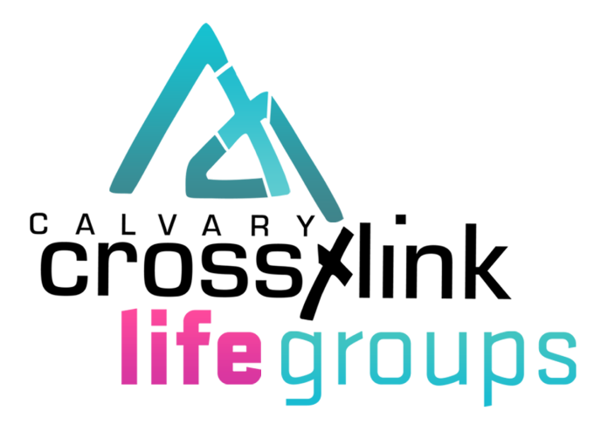

Vision & Purpose Statement

Life Groups @ Cross-link Vision Statement
A Vibrant Life Groups @ Cross-link that will Impact the Valley and Bless the Nations by Reaching people with the gospel of Jesus Christ, Teaching them the Word of God, and Ministering to their needs.

Life Groups @ Cross-link Purpose Statement
The Life Groups @ Cross-link exist to Reach the Valley and the Nations with the gospel of Jesus Christ, to Teach each member of our small groups to obey the Word of God, and to Minister to the needs of people.

Life Groups @ Cross-link Strategy
We will accomplish the Vision and Purpose of our Life Groups @ Cross-link by:
- Reaching people with the gospel of Jesus Christ and for Church Membership and Bible Study
- Teaching people to obey God’s Word
- Ministering to people’s needs
- Developing new leaders who can lead new small groups that Reach, Teach, and Minister
- Multiplying small groups that Reach, Teach, and Minister

Reaching People Strategy
Each small group will have an Outreach Leader who:
- organizes the Life Group for Missions and Outreach
- Leads the class to outreach by participating in and leading others to participate in the organized outreach program of our church
- Leads the outreach time during the Life Groups meeting
- Attends leadership training meetings
- Supports the Vision, Purpose, and Strategy of the Life Groups

Teaching People Strategy
Each small group will have a teacher who leads the class by:
- Teaching the Word of God
- Leading the class to Outreach and Care for one another
- Recruiting Outreach and Care Group Leaders and getting them the training they need to succeed
- Shepherding their small group
- Attending leadership training meetings
- Supports the Vision, Purpose and Strategy of the Life Groups

Ministering to People Strategy
Each small group will have a Care Group Leader who leads his care group to:
- Minister to a group of 6 – 10 people
- Pray for one another
- Reach out to those who have missed 2 or more Life Group meetings
- Contact one another throughout the week
- Care for those who are sick, in the hospital, pregnant, or grieving
- Attending leadership training meetings
- Support the Vision, Purpose, and Strategy of the Life Groups

